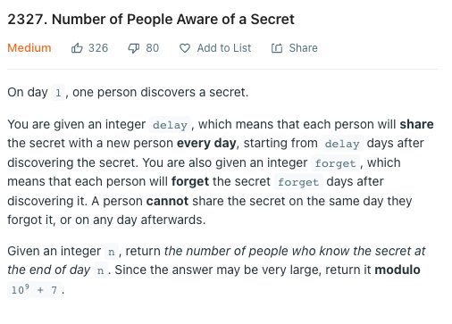

My Idea:

Key point

Tracking the number of ppl who just know the secret every day -> for future forget/sharing purpose  
Tracking the number of ppl who know the secret  
Tracking the number of ppl who can share the secret

For every day

find the number of ppl forget and start to share the secret on that day

then update those 3 quantities